|  |  |  |
| --- | --- | --- |
| Large Scale Data Driven Applications | Interactive Dashboard Documentation | Version 1.0 |
| Sameer Uddin  20004135 |

Contents

Purpose 2

Design 2

Figure 1 - Homepage Design 2

Figure 2 - Patients Page 3

# Purpose

The purpose of this coursework is to implement the learnings from the first part of this coursework into an interactive dashboard that can be used by the clinic to gain valuable insight into their patients, appointment history and how this may affect no-shows for appointments. The dashboard should help the clinic gain insight into various factors that can affect no-shows by factors such as patient demographic, medical conditions, reminder effectiveness and appointment history.

The interactive dashboard will visualise data by using graphs (D3.js) and give the clinic filtering options to further explore what contributes to no-show rates. The graphs and information provided should also help the clinic identify what is causing no-show rates and should give them ideas on what can be done to reduce these.

The ultimate objective of this dashboard is to help reduce no-shows which should improve the overall quality of service that can be provided by the clinic. This will be achieved by increasing the patients turn out rate and reducing the amount of time that is wasted. This dashboard will provide the clinic and its staff with key information to increase their efficiency.

# Design

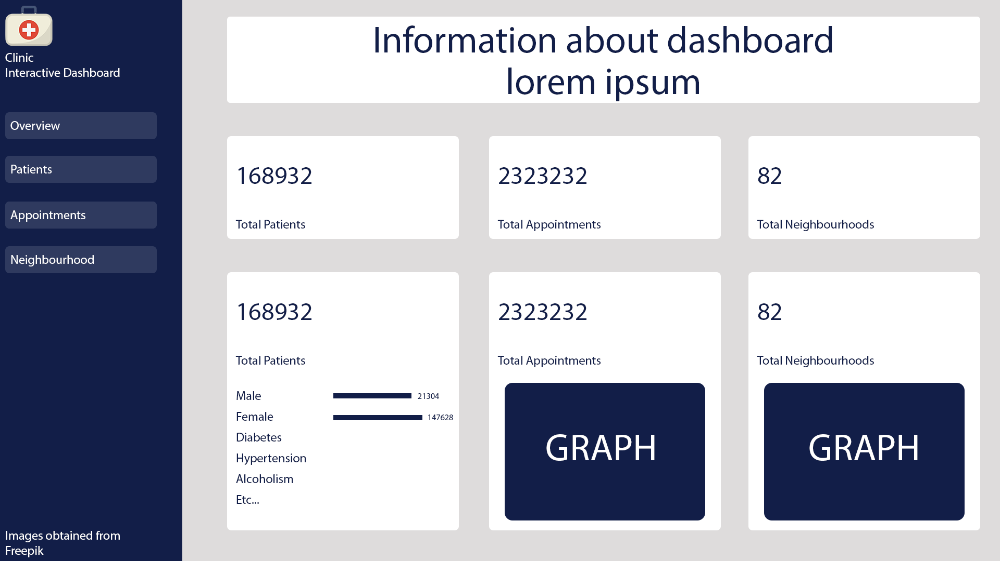

Figure - Homepage Design

The landing page or the home page will act as an overview of the database. It will provide insight into the data. This page will offer quick access to important metrics and include graphs that users can view to get a quick overview of the database.

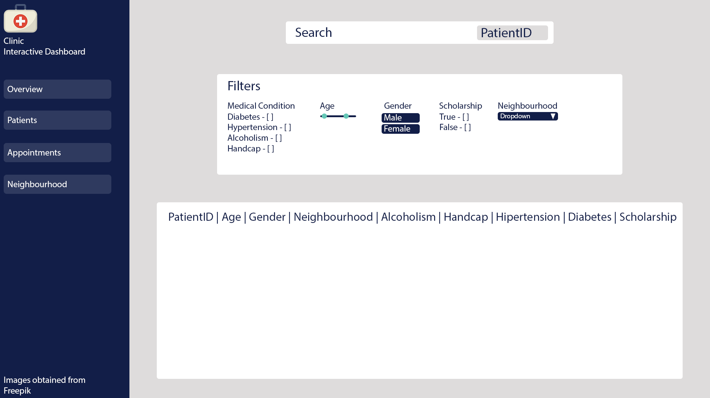

Figure - Patients Page

This page will provide information on the patients in the database. This page will not provide information on appointment history. This page will allow the clinic to search for patients based on their ID (as name is not available). They can also filter the table by other categories such as medical conditions, age, gender, scholarship and neighbourhood.

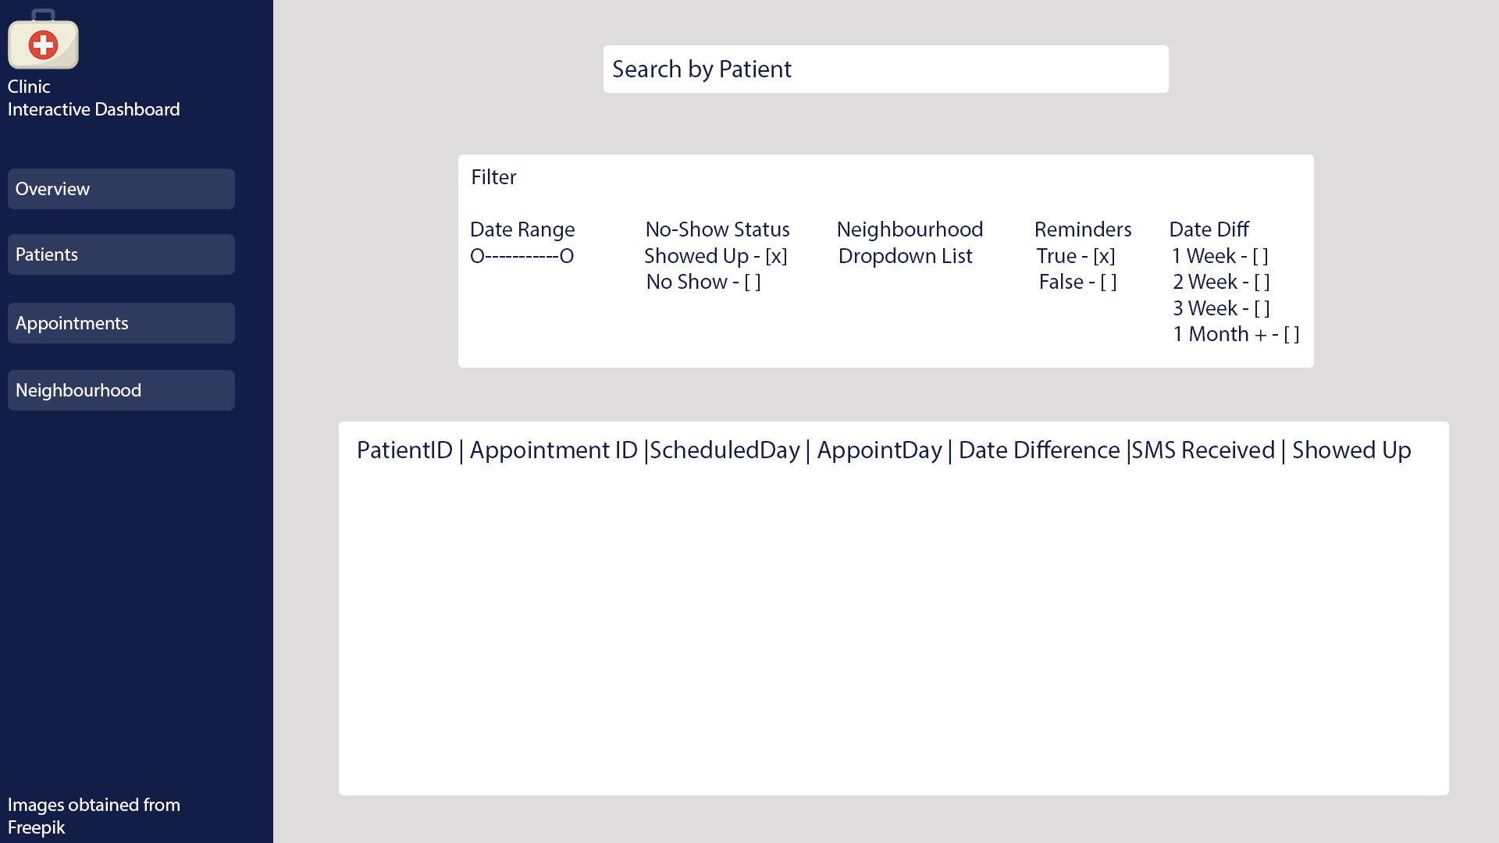

Figure - Appointments Page

This page will provide information on appointments. The table will have key information on appointments such as the patients ID, appointment ID and other information like key dates. Based on the design the user should be able to filter by date range, show status, neighbourhood, reminders and the date difference between booking date and scheduled date.

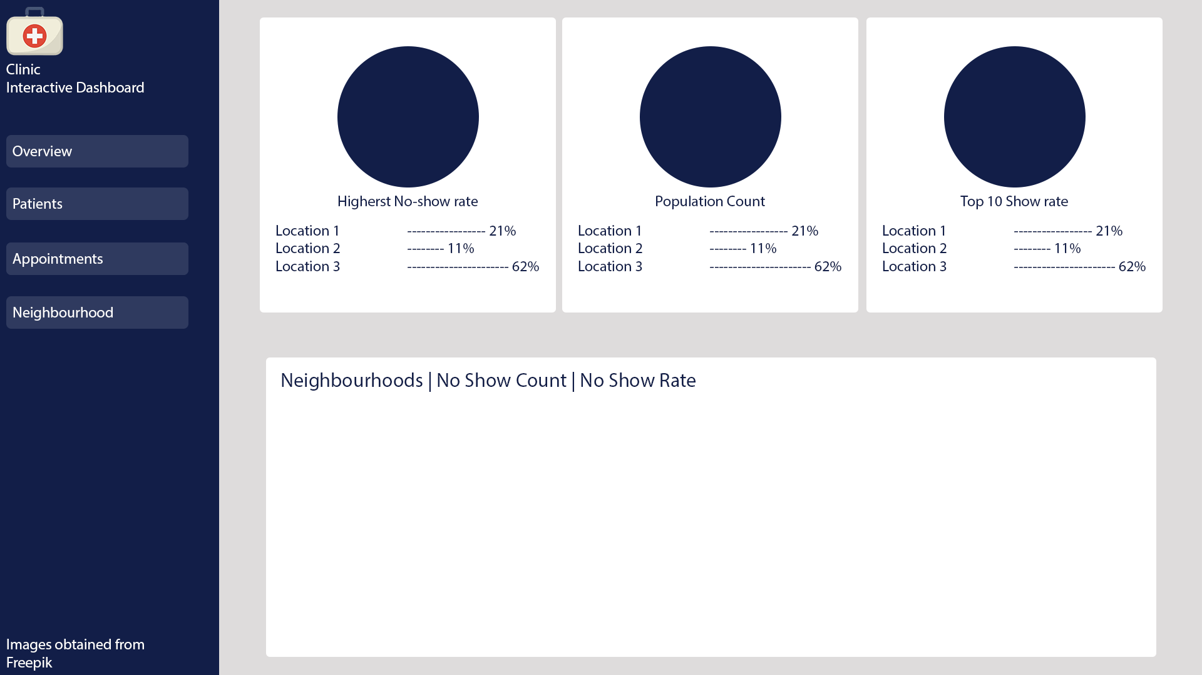

Figure - Neighbourhood Page

This page will provide information on neighbourhoods. This page should have a table with all the lists of neighbourhoods and provide key information based on these neighbourhoods. This page will display metrics such as the neighbourhoods with the highest no-show rates, population of each neighbourhood and the neighbourhoods that have the lowest no-show rates.